Steps
After reviewing the resources for this assignment, do the following steps…
1: Start a Word document, making sure you start with your name, the assignment name and the due date.
2a: For Windows PCs, install Kali Linux using the available VDI:
- Go to the Virtual Machine download section of the Kali Linux website.
- Following the instructions, install Kali Linux using the VDI available on the website in your VirtualBox installation.
- Once Kali Linux is installed, take a screenshot of the desktop in the VirtualBox.
- Insert the screenshot into the Word document.
2b: For Mac Users, install Kali Linux from the available ISO:
- Go to the Mac Download section of the Kali Linux website
- Download the ISO for the appropriate CPU in your Mac. Most newer makes will use the Apple Silicon (ARM64).
- In VirtualBox, set up a Virtual Machine as follows:
  - Click the “New” button
  - Insert a name (e.g. KaliTest)
  - Select the downloaded ISO for ISO Image
  - Ensure Type is Linux
  - Change Subtype to Debian
  - Ensure Version is Debian (ARM 64-bit)
  - Under Hardware, set Base memory to at least 4096MB, and Processors to at least 4.
  - Under Hard Disk, allot at least 20GB to the Virtual Hard Drive
  - Click Finish.
- Start the VM
- Choose “Graphical Install” and then answer the questions for installation.
  - You can change the hostname or leave it as the default.
  - Make up a domain name (e.g. mytestnetwork.net)
  - Enter your name in the User, and you can accept the default username.
  - Enter a password twice.
  - Choose Guided – Use the Entire Disk under partitions.
  - Chose default settings until you are asked whether or not to do the action, then change it to yes.
  - The base system will now be installed.
  - Choose the default settings for the Desktop Environment
  - Reboot the VM
- Login using your username and password
- Once Kali Linux is installed, take a screenshot of the desktop in the VirtualBox.
- Insert the screenshot into the Word document.
3: Review the security tools available in the menu for Kali Linux.
- Choose the top 10 tools in the menu that you think you would use as an IT Professional and list them and their purpose in the Word document.
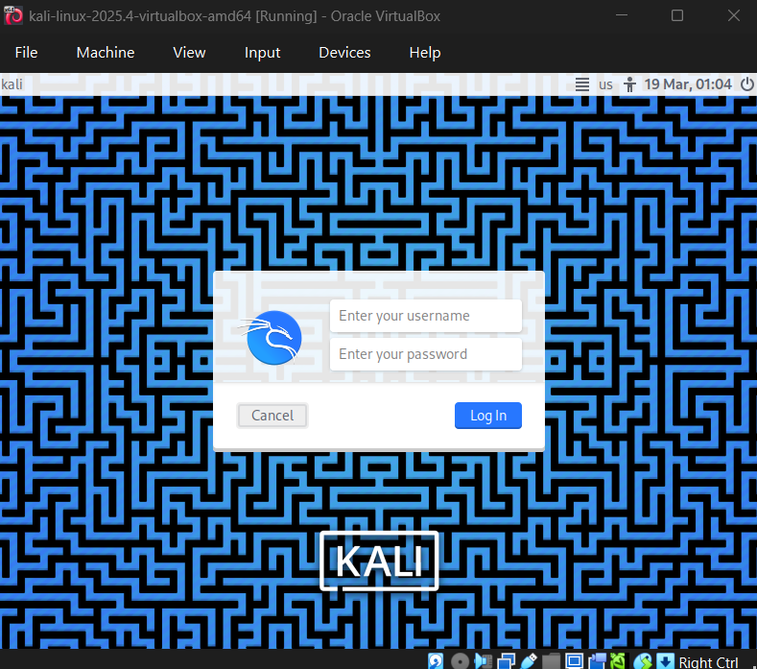
Review the security tools available in the menu for Kali Linux.
- Choose the top 10 tools in the menu that you think you would use as an IT Professional and list them and their purpose in the Word document.

- Nmap (Network Mapper)
It can be used for network discovery and security auditing. It does this by helping identify open ports, running services, and potential vulnerabilities in a network.

- Wireshark
A packet analysis tool that captures and inspects network traffic in real time. It is useful for troubleshooting, detecting suspicious activity, and analyzing protocols.

- Metasploit Framework
A penetration testing tool used to find and validate vulnerabilities in systems. It also helps test security defenses.

- Burp Suite
A web application security testing tool used to intercept and analyze HTTP traffic. It is used to identify vulnerabilities like SQL injections and cross-site scripting.

- Aircrack-ng
Tools for assessing Wi-Fi security. It can capture packets and crack weak wireless encryption.

- John the Ripper
A tool for password cracking that is used to test password strength by attempting to recover passwords from hashes.

- Hydra
A fast network login cracker that performs brute force attacks on protocols like SSH, FTP, and HTTP.

- Nikto
A web server scanner that finds vulnerabilities, outdated software, and misconfigurations in web servers.

- SQLmap
An automated tool used to detect and exploit SQL vulnerabilities in web applications.

- Netcat
A networking tool used for reading and writing data across network connections. It can be used for debugging, port scanning, and backdoor communication.

